A Motion Correction System for Brain Tomography Based on Biologically Motivated Models

Sergey Anishenko¹, Vladislav Osinov¹, Dmitry Shaposhnikov¹,
Lubov Podladchikova¹, Richard Comley², Konstantin Sukholentsev², Xiaohong W. Gao²

¹A.B.Kogan Research Institute for Neurocybernetics, Southern Federal University,
Rostov-on-Don, Russia, dima@nisms.krinc.ru

²School of Computing Science, Middlesex University, London, NW4 4BT, UK, X.Gao@mdx.ac.uk

Abstract—A motion correction system for brain tomography is presented, which employs two calibrated video cameras and three vision models (CIECAM’97, RETINA, and BMV). The system is evaluated on the pictures monitoring a subject’s head while simulating PET scanning (n=12) and on the face images of subjects with different skin colours (n=31). The results on 2D images with known moving parameters show that motion parameters of rotation and translation along X, Y, and Z directions can be obtained very accurately via the method of facial landmark detection. A feasibility study of the developed algorithms is evaluated by a computer simulation of brain scanning procedures.

- INTRODUCTION
Data acquisition from positron emission tomography (PET) is a relatively lengthy procedure (up to 1 hour) and it is difficult for a subject to stay still during the brain scanning. Head motion can significantly degrade the quality of PET studies [1-10]. Furthermore, head motion also causes misalignment between the emission and transmission scan data, leading to erroneous correction for photon attenuation [10]. The known methods [5, 7, 8] to reduce the degradation effect of motion fall into several categories: image realignment in frame-mode or list-mode correction, optical tracking systems by devices mounted on a patient’s head, and their combinations. In our study, a new approach to develop a motion correction system for brain tomography is proposed. It is based on two calibrated cameras and three biologically motivated models. One model is CIECAM [11, 12] for measuring colour appearance invariantly to illuminating conditions. The second one is a Behaviour Model of Vision (BMV) simulating some mechanisms of the human vision system for perceiving shapes [13]. The third model is a simplified retina-like model for motion detection [14]. These models are used for colour segmentation of facial area on initial pictures, detection of local facial landmarks (i.e. eye corners and middle point of nose basement), and motion moment determination respectively. In the previous papers, the basic algorithms and overall system architecture have been developed [15-17]. In this paper, some modifications to this system and new computer simulation results are presented. Future directions to develop the system also are proposed.

- SYSTEM ARCHITECTURE
The proposed system (Figure 1) includes four basic modules: (1) input; (2) face segmentation; (3) local facial landmarks detection; (4) head movements estimation. These modules are implemented as a set of devices (the first one), software packages (the second and the third ones), and a set of algorithms (the fourth one).

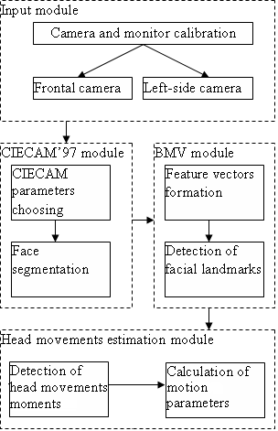
Figure 1. The overview of the system for head motion detection.

Input module
Input module consists of two off-the-shelf digital cameras, Canon EOS-1D Mark II, to monitor the head movement on a subject performing a PET brain scan. Before the shooting, cameras and colour monitors are calibrated because both main algorithms (i.e. face segmentation and facial landmark detection) is based on facial skin colours. Figure 2 illustrates the steps of camera calibration.

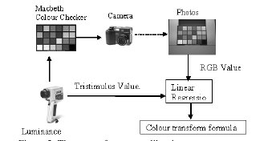
Figure 2. The steps of camera calibration.

First, the camera takes pictures of 24 colour patches from Macbeth Colour Checker. These images are then transferred to a calibrated colour monitor. The 24 colour patches are then measured using colour meter CS-100A to obtain their CIE XYZ values. The two sets of XYZ values are then used to obtain camera calibration model by the least square method.
The calibration of the colour monitor is done by using optical software with Spyder sensor. When an image is downloaded to a computer, it is presented in a RGB space. To convert RGB space to CIE standard XYZ space, which is the connection space and the starting point for the application of CIECAM, Eq. (1) is applied under CIE standard illuminant D65, the average daylight. The reference white is [Xw, Yw, Zw] = [0.95045 1.0 1.088754].

$\left[\begin{matrix}X \\ Y \\ Z\end{matrix}\right]=\left[\begin{matrix}\begin{matrix}0\text{.}\text{412453} & 0\text{.}\text{357580} & 0\text{.}\text{180423}\end{matrix} \\ \begin{matrix}0\text{.}\text{212671} & 0\text{.}\text{715160} & 0\text{.}\text{072169}\end{matrix} \\ \begin{matrix}0\text{.}\text{019334} & 0\text{.}\text{119193} & 0\text{.}\text{950227}\end{matrix}\end{matrix}\right]\left[\begin{matrix}R \\ G \\ B\end{matrix}\right]$ (1)

Face segmentation module
In the implementation, the ranges of colour attributes of hue, chroma, and lightness calculated by CIECAM, which are the property of facial skin colour, can be gained by two approaches showing as below:
1) Use of the average of the estimations estimated by the observers visually on a range of skin colours.
2) Obtain the colour range for the first image of a sequence picture for a given subject.
These ranges are then applied as a threshold to segment the head from the rest of the pictures. The result the way face segmentation module works is presented in Figure 3.

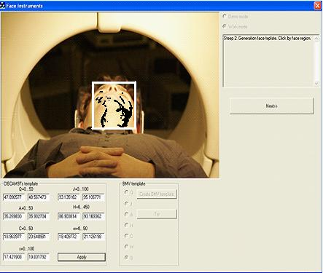
Figure 3. The module for face segmentation.

Facial landmarks detection module
According to the preliminary evaluation, eye corners and the middle point of a nose basement are chosen as facial landmarks in the consideration that they are a set of relatively constant local features. In computer implementation, feature description of each facial landmark (Figure 4) is formed by space-variant input window and represented by multidimensional vector. The vector components are values of primary features detected in the vicinity of each of 49 input window nodes Ai , i=0, 1…48. Each component of feature vectors is in line with the orientation of local “colour” edge detected from colour attributes (lightness, chroma, and hue) that are extracted by convolving a map with a set of 16 kernels. Each kernel is sensitive to one of 16 chosen orientations. The whole set of 16 kernels are determined by differences between two oriented Gaussians with shifted kernels.

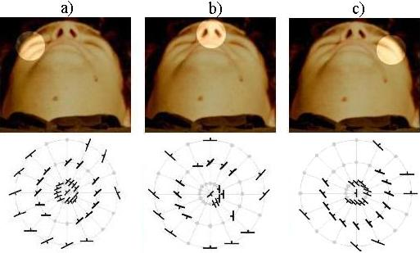
Figure 4. Feature vectors of facial landmarks for a subject: (a) right eye corner, (b) middle point of nose basement, (c) left eye corner.

Initial estimation of each chosen landmark is obtained by single positioning input window in the centre of a corresponding region on one image only for each subject, and works as a template feature vector. Then all consequent images of the same subject are processed by input window to search image points with feature vectors similar to the template feature vector. Figure 5 demonstrates the result by the module of facial landmark detection.

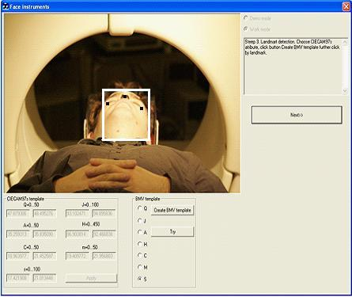
Figure 5. The module for local facial landmarks detection.

Head motion estimation module
Head motion estimation module is mainly realized as a set of algorithms and in part is implemented in the computer system. In the first sub-module, the moments that head movements occur are detected by a simplified retina-like model (Figure 6 [14]). Then in these moment pictures, the positions of local facial landmarks on pictures X and Y axes as well as linear and angular relations between them are calculated and compared with those in the initial picture. The scheme for the calculation of head movements is presented in Figure 7.

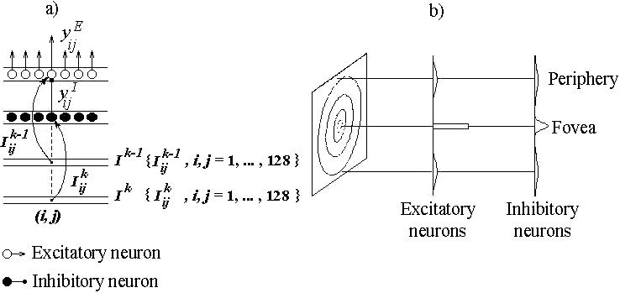

Figure 6. Connection structure in the retina-like model (a) and schematical representation of input weights distributions and receptive field sizes of excitatory and inhibitory neurons for foveal and peripheral modules of the space-variant visual preprocessor (b).

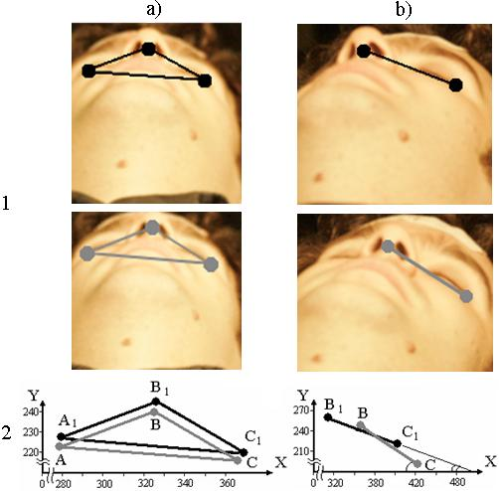
Figure 7. Spatial relations (1) between facial landmarks detected on consecutive pictures and their scheme (2): a) pictures captured by frontal camera (A, B, C and A1, B1, C1 - landmarks identified); b) pictures captured by the left camera. In (2) the pixels of initial picture (upper row) are presented on X and Y axes.

- COMPUTER SIMULATION
Two sets of image data have been employed in the computer simulation. The first image collection (n=12) with a subject lying down in the PET scanner includes the pictures with known head positions (measured by the build-in red laser beam of the PET scanner) and illumination conditions. All pictures monitoring a subject’s head while simulating PET scanning had the same dimension (640x427 pixels) and are recorded by the calibrated cameras. The second collection contains pictures of the human faces with various skin colours (n=31). This collection of images has various resolutions and is recorded by cameras without any calibrations.
During the computer simulation, face areas are correctly segmented on all images in the first collection without false positive regions. Furthermore, all the visible facial landmarks (n=30) have been identified with very high precision (1±0.64 pixels). After the detection of facial landmarks, the movement parameters including translation and rotation along each of X, Y, and Z axes can be determined by comparison of landmarks from two consecutive images of the same subject undergoing the same scanning. Estimations on 2D images with known moving parameters show that motion parameters can be obtained very accurately. For example, the rotation angle for the two pictures presented in Figure 7 is equal to 10°. While processing the pictures from the second collection, many false positive regions are identified (n=25) among face areas (n=31), arriving at that only 56 out of 88 visible facial landmarks being detected correctly.
A software module simulating the PET scanning procedure has been developed for quantitative estimation of different factors contributing to the system performance (Figure 8). It includes 3D model of a head that may be rotated in any axis (Figure 9).
Preliminary tests indicate that it is possible to preserve one degree precision of rotated angle based on the estimation of dynamical geometrical parameters between facial landmarks. The range of geometrical parameters to be more sensitive to motion is determined for the front and left side cameras. In particular, angles between facial landmarks (see Figure 7.2) for the front camera are more sensitive to pitch change (see Figure 9). The simulator will give an opportunity to develop motion correction algorithms for simultaneous processing of the pictures taken by the cameras located in front and left hand side.

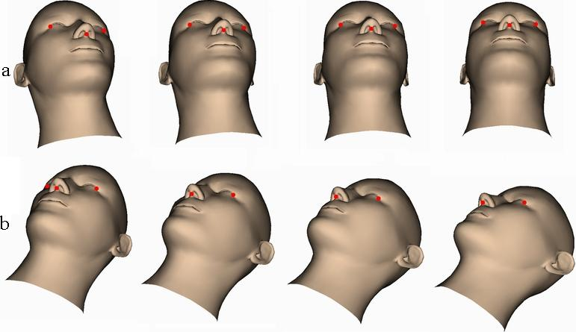
Figure 8. Head movement simulation, а) frontal camera, b) left side camera.

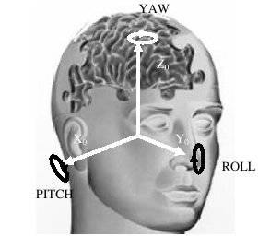

Figure 9. The co-ordinate system for detection of head movement.

- CONCLUSION
In our study, a new approach to monitor the human head motions during PET scanning based on three biologically motivated vision models, i.e. CIECAM`97 [11, 12], RETINA [14] and BMV [13] has been developed. The computer simulation results have shown very good performance of the developed system in processing the pictures captured by calibrated cameras. In particular, centres of chosen facial landmarks, including eye corners and middle point of nose basement, are detected with very high precision. Preliminary estimations on 2D images with known moving parameters show that the movement parameters (i.e. rotation and translation along X, Y, and Z axes) can be obtained very accurately via analysis of spatial and angular relations between identified facial local landmarks.
The future steps to improve the system performance are to be followed. First of all the system must be evaluated on large number of subject data with different range of skin colours. Secondly, the images taken from the second camera should be analysed simultaneously with the images taken from the first camera, which is still under investigation at the moment. Thirdly, correct method for motion moment identification (e.g., by retina-like model or vibraimage system [21]) will be developed. It is supposed that the contour detection [18], approach for face superposition [19] and the comparison of two symmetrical facial lines of two consecutive images [20] are applied. In this way, the head movements with demanded exactness can be improved based on the detection of facial landmark. Finally, the detected motion parameters will be utilized in the process of PET brain image reconstruction, which requires list-mode (event-by-event data acquisition) data. During the implementation, all the steps listed above will be employed in the software simulator (see Figure 8) as additional tools.

Acknowledgment
This work is funded by the BRIDGE Research Cooperation Award by British Council on Head Motion Detection. The authors would also like to thank Dr. Stephen Batty for being the subject simulating the PET scanning.

References
- P.M. Bloomfield, T.J. Spinks, J. Reed, L. Schnoor, A.M. Westrip, L. Livieratos, R. Fulton, T. Jones, “The Development of a Motion Correction System in Neurological PET Using List Mode Data Acquisition and a Polaris Tracking System”, Neuroimage, no. 16, 2002, S15.
- P. Bühler, U. Just, E. Will, J. Kotzerke, and J. van den Hoff, ”An Accurate Method for Correction of Head Movement in PET”, IEEE Transaction on Medical Imaging, v. 23, iss. 9, 2004, pp.1176-1185.
- M.V. Green, J. Seidel, S.D. Stein, T.E. Tedder, K.M. Kemper, C. Kertzman, T.A. Zeffiro, “Head Movements in Normal Subjects During Simulated PET Brain Imaging With and Without Head Constraint”, J Nucl Med, no. 35, 1994, pp.1538-46.
- B.F. Hutton, A.Z. Kyme, Y.H. Lau, D.W. Skerrett, R.R. Fulton, “A Hybrid 3-D Reconstruction/registration Algorithm for Correction of Head Motion in Emission Tomography”, IEEE Trans. Nucl. Sci., no. 49, 2002, pp. 188-194.
- A. Rahmim. “Advanced Motion Correction Methods in PET. Review Article”, Iran J. Nucl. Med., v. 13, no. 241, 2005, pp.1-17.
- U.E. Ruttiman, P.J. Andreassen, D. Rio, “Head Motion During Positron Emission Tomography: Is it Significant?”, Psychiatry Res: Neuroimaging, no. 65, 1995, pp. 41-43.
- L. Tellmann, R. Fulton, U. Pietrzyk, I. Nickel, I. Stangier, O. Winz, H. Herzog, “Concepts of Registration and Correction of Head Motion in Positron Emission Tomography”, Z Med Phys., v. 16, no. 1, 2006, pp. 67-74.
- H. Watabe, K. Koshino, P.M. Bloomfield, R.R. Fulton, H. Iida, “Development of Motion Correction Technique for PET Study Using Optical Tracking System”, International Congress Series, 1265, 2004, pp. 31 – 38.
- R.P. Woods, S.R. Cherry, J.C. Mazziotta, “Rapid Automated Algorithm for Aligning and Reclining PET Images”, J Comput Assist Tomogr, no. 16, 1992, pp. 620-633.
- H. Zaidi, M.-L. Montandon, and S. Meikleb, “Strategies for Attenuation Compensation in Neurological PET Studies. Review”, NeuroImage, no. 34, 2007, pp. 518 – 541.
- CIE, The CIE 1997 Interim Colour Appearance Model (Simple Version), CIECAM97s, CIE TC1-34, April, 1998.
- M.R. Luo, and R.W.G. Hunt, “The Structure of the CIE 1997 Colour Appearance Model (CIECAM97s)”, Color Res. Appl., no. 23, 1998, pp. 138-146.
- I. Rybak, V. Gusakova, A. Golovan, L. Podladchikova, N. Shevtsova, “Attention-guided Recognition Based on «What»; and «Where» Representations: A Behavioral Model”, Neurobiology of Attention, Elsevier, 2005, pp. 663-670.
- Shevtsova N. A., Golovan A. V., Podladchikova L. N., Gusakova V. I., Shaposhnikov D.G., Faure A. Estimation of Motion Parameters by Retina-Like Neural Network Model. Neurocomputers for Image and Signal Processing, Springer Verlag GmbH, 2008 (in press).
- Anishchenko S., Osinov V., Shaposhnikov D., Podlachikova L., Comley R., Gao X.W. Toward a Robust System to Monitor Head Motions during PET Based on Facial Landmark Detection: a New Approach. In proc. of Conf. Biomedical Sys., Finland, 2008 (in press).
- X. Gao, S. Batty, L. Podladchikova, D. Shaposhnikov, and J. Clark, “Detection of Head Motions Using a Vision Model”, Proc. of International Conference on Telehealth, Canada, 2007, pp. 167-171.
- X.W. Gao, S. Anishenko, D. Shaposhnikov, L. Podladchikova, S. Batty, and J. Clark. “High-precision Detection of Facial Landmarks to Estimate Head Motions Based on Vision Models”, Journal of Computer Science, v. 3, no. 7, 2007, pp.528-532.
- X.W. Gao, L. Podladchikova, D. Shaposhnikov, K.Hong, N. Shevtsova, “Recognition of Traffic Signs Based on Their Colour and Shape Features Extracted Using Human Vision Models”, J. Vis. Commun. Image R., no. 17, 2006, pp. 675-685.
- D.G. Shaposhnikov, L.N. Podladchikova, X. Gao, “Classification of Images on the Basis of the Properties of Informative Regions”, Pattern Recognition and Image Analysis: Advances in Mathematical Theory and Applications, v. 13, 2003, pp.349-352.
- X.W. Gao, S. Batty, J. Clark, T. Fryer, A. Blandford, “Extraction of Sagittal Symmetry Planes from PET Images“, Proc. of the IASTED Int. Conf. on Visualization, Imaging, and Image Processing (VIIP'2001), ACTA Press, 2001, pp. 428-433.
- http://www.elsys.ru/vibraimage_e.php

